Smart Home Power Consumption Forecasting
Muhammad Miftah Faridh, and Yeong Min Jang
Department of Electronics Engineering, Kookmin University
Seoul, South Korea
Email : muhammadmiftahfaridh@gmail.com; yjang@kookmin.ac.kr

Introduction
It will be impossible for humans to survive if they continue to rely on harmful fossil fuels; consequently, a renewable energy system is being created. Using a smart meter and forecast system we can estimate the electricity needs of a region in advance. Electricity demand may be successfully predicted using forecasting models that use time series weather data. For ten areas in South Korea, we utilize conventional algorithms such as Arima and Arimax and modern algorithms like the deep learning model LSTM.

Methodology
To train a deep learning model, it is necessary to use data that aligns with the experiment's goals. We used dataset from Kaggle, with name Smart Home Dataset with weather Information. The data collected from smart meter in smart home environment after that the data sent to the database via MQTT. As we can see in this figure below we can see the data distribution.
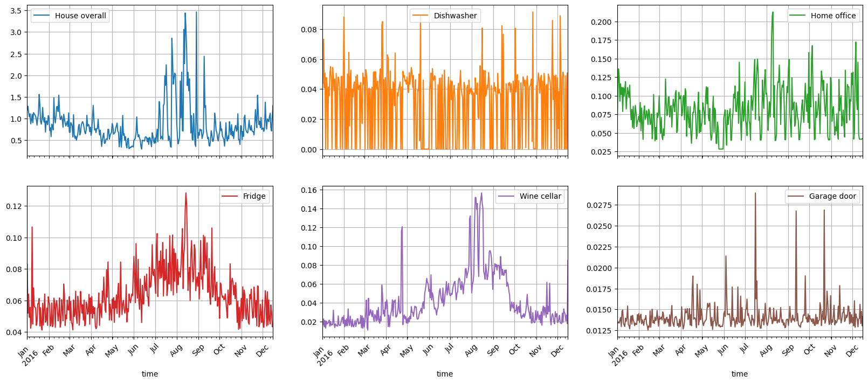
Figure 1 Energy Data Distribution
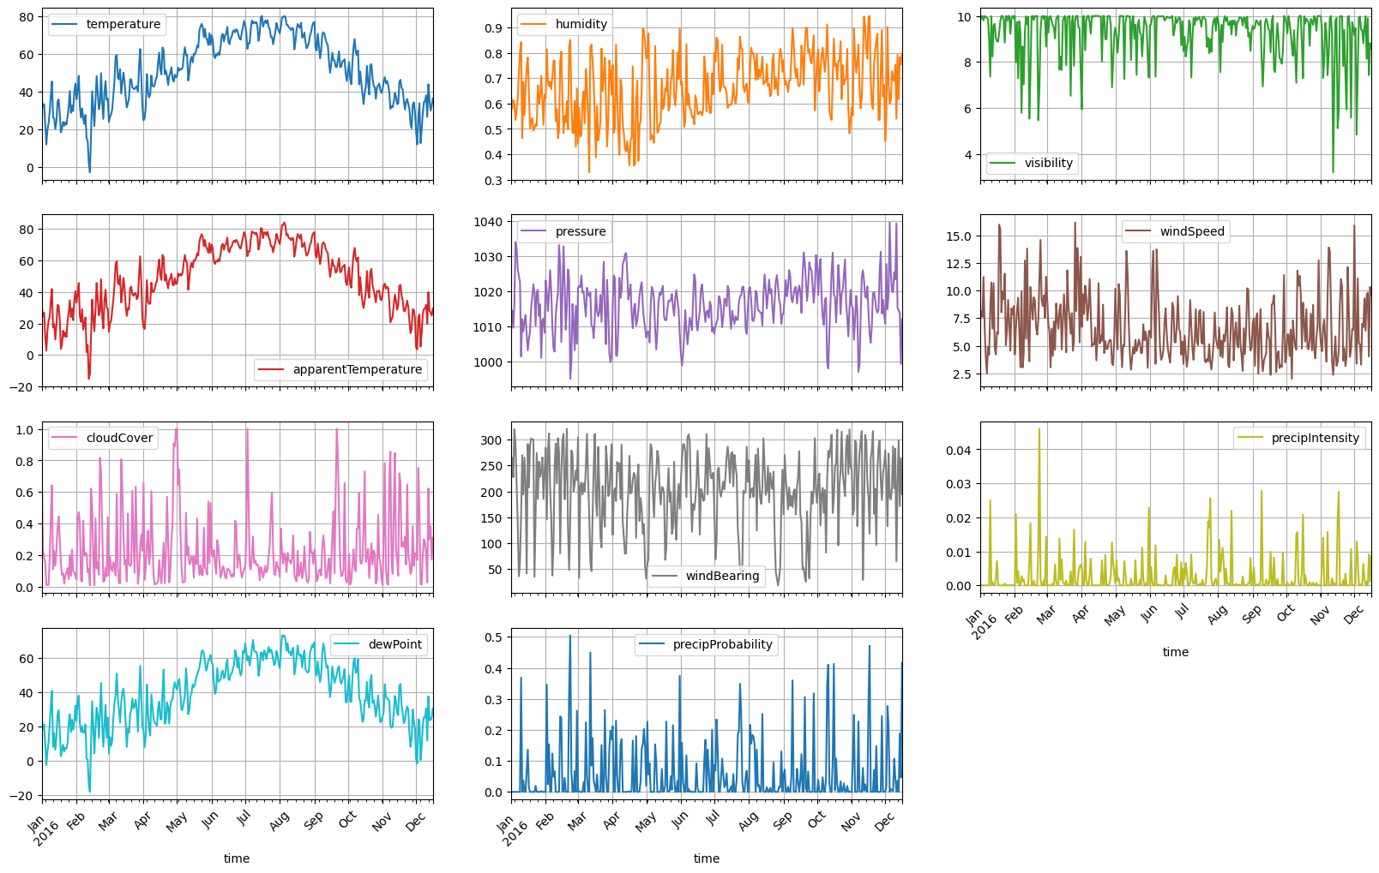
Figure 2 Weather Data Distribution

System Overview

Data Preprocessing
After collecting data, it must be preprocessed due to the data's sensitivity to variations in power generation. We must interpolate some missing data using the nearest approach.- Then, the data are normalized using the MinMax method (equation 1), the -1 to 1 rescaling approach. Then, we exclude features in the weather data by determining the best correlation between the data (figure 3 and figure 4). Consequently, we only use data from inputs such as temperature, relative humidity, solar radiation, sunshine in seconds per hour, and precipitation per hour. After that we do outlier data deletion (figure 5).
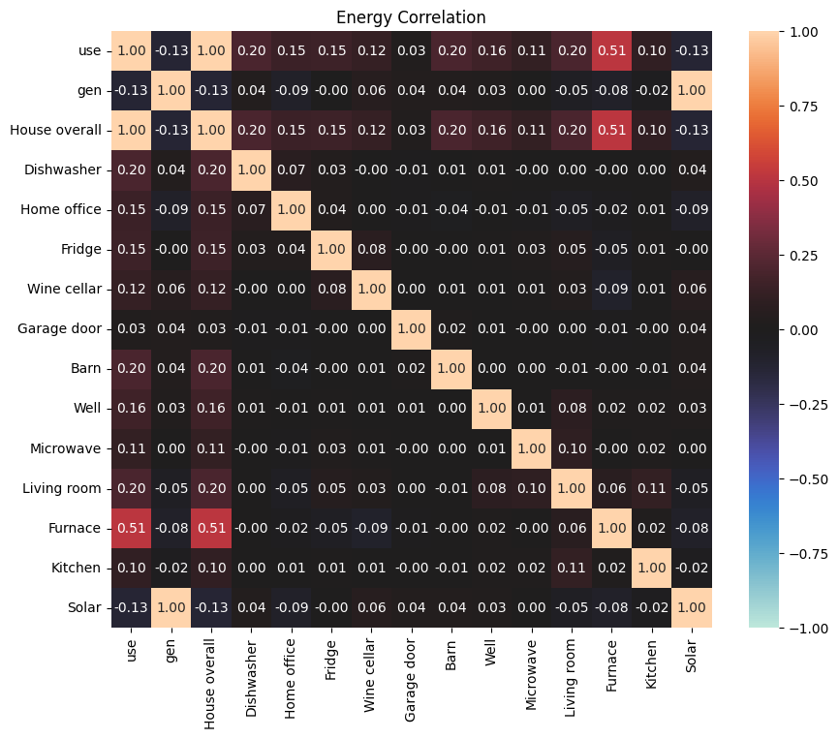
Figure 3 Energy Correlation
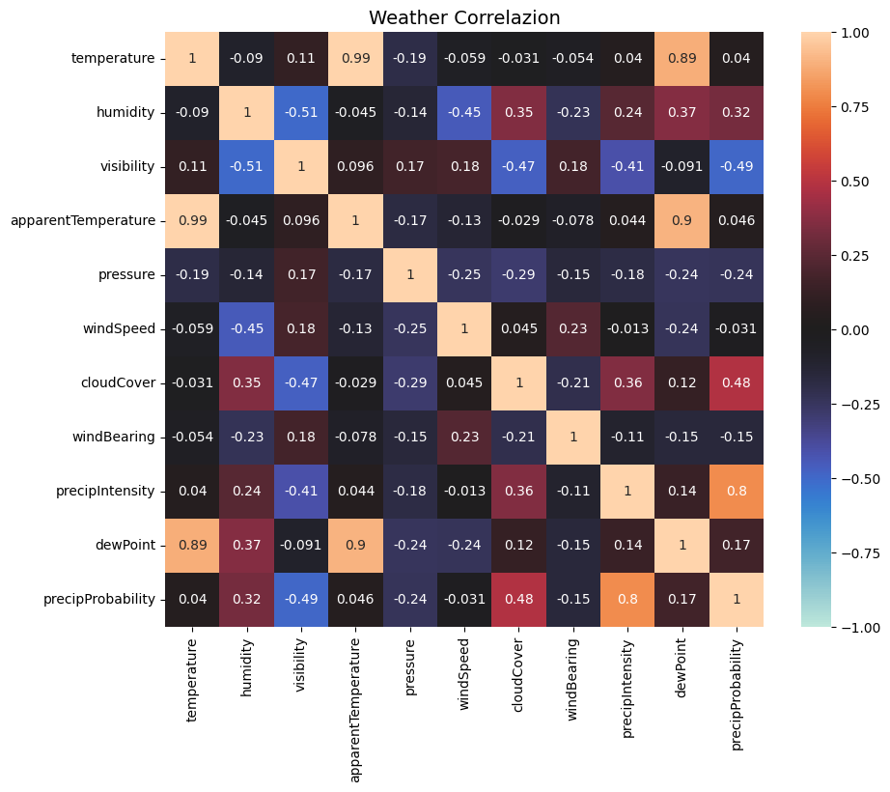
Figure 4 Weather Correlation
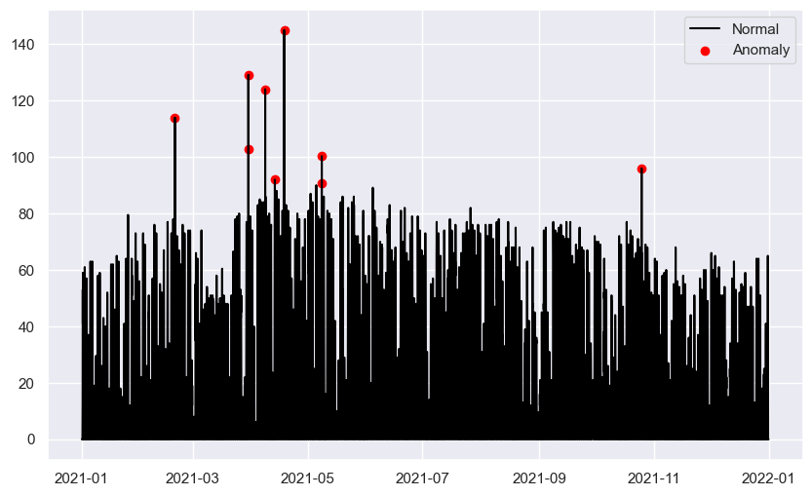
Figure 5 Outliar Deletion
To create a sequence-to-sequence, we turn the input into a sliding window format. The sliding window data will consist of the previous month's and prior week's data for the future. Finally, we divide the data into three sections of corresponding sizes: training data, data validation data, and test data.
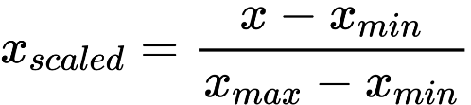 (1)
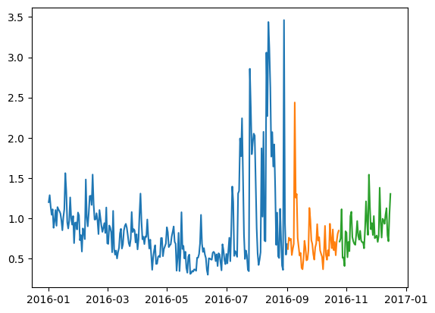
Figure 6 Data split ratio

Deep learning-based on Power Generation forecasting
This paper uses the deep learning model, such as Arima basic, Arima dynamic, Sarima, Sarimax, LSTM Univariate, and LSTM Multivariate. They are all combined with a dense layer. In this experiment, we utilize several ANN models to identify compatibility with the input data, weather data. We set the batch size to 32, the hyperparameter Adam as the optimizer with a learning rate of 0.001, the iteration to 200, and the callback function to terminate if the data has already reached convergence or is close to overfitting.

Performance Maetrics
We present several findings regarding the predicted timeliness of time series data. Loss, validation loss, and mean square error (MSE) are the essential measures for evaluating a model's quality. The RMSE, the mean absolute error (MAE), and the regression score (R-squared or R2 score) were used to evaluate the accuracy of the predictions. We use the following equation to determine the error metrics.
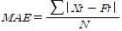 (2)
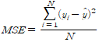 (3)
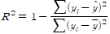 (4)

Experimental Result
Classical forecasting methods like ARIMA and HWES are still popular and powerful but they lack the overall generalizability that memory-based models like LSTM offer we can see based on our result in this table below.
Table 1 Perform Model
Model | MSE | RMSE | MAE | R2
Arima_basic | 0.259 | 0.509 | 0.463 | 0.722
Arima_dynamic | 0.069 | 0.263 | 0.176 | 0.229
Sarima | 0.107 | 0.327 | 0.266 | 0.397
Sarimax | 0.101 | 0.317 | 0.243 | 0.363
LSTM_Univar | 0.068 | 0.261 | 0.173 | 0.307
LSTM_Multivar | 0.022 | 0.150 | 0.110 | 0.173

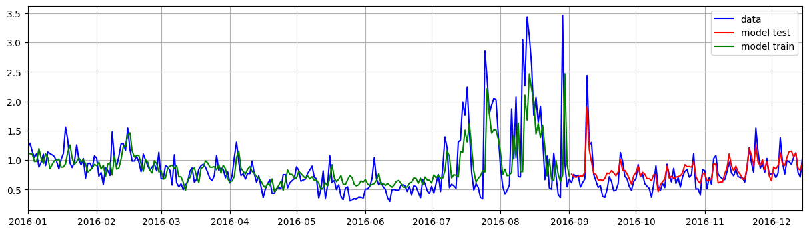
Figure 7 Prediction Output
The LSTM rectifies a huge issue that recurrent neural networks suffer from: short-memory. Using a series of ‘gates,’ each with its own RNN, the LSTM manages to keep, forget or ignore data points based on a probabilistic model. Univariate single step type. Using past values, we will predict only one value for the future. We can divide the sequence into multiple inputs/output patterns, converting the sequence to a supervised learning problem. From the division of data in the input/output pattern, the model will learn about the input patterns and the output, a single step output. And we can get the prediction or forecast model like as shown in figure 7.

Conclusion
This work provides a comparison model employing several data from smart home using smart meter. LSTM has proven in this work that LSTM multivariate outform in the every performance sections. In the future, we will offer techniques that use anomaly detection analysis (Figure 8) on the predictions that will be issued by the model.

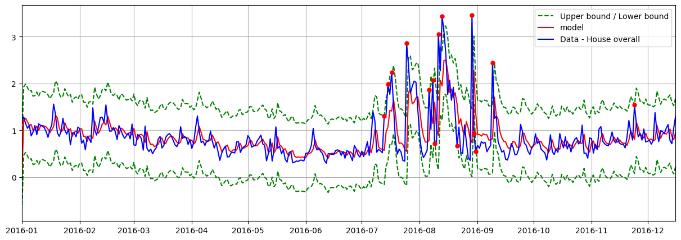
Figure 8 Anomaly Detection

